Module 1
Introduction & Entity Relationship (ER) Model
Syllabus
Concept & Overview of Database Management Systems (DBMS) - Characteristics of Database system, Database Users, structured, semi-structured and unstructured data. Data Models and Schema - Three Schema architecture. Database Languages, Database architectures and classification.
ER model - Basic concepts, entity set & attributes, notations, Relationships and constraints, cardinality, participation, notations, weak entities, relationships of degree 3.
- Data, Database & DBMS
Data
- Known facts that can be recorded and have implicit meaning
- Ex: Names, Telephone numbers and Addresses of the people you know.
Database
- The collection of related data
- Ex: You can store information of people in an indexed address book.
Database implicit properties
- Universe of discourse(UoD) or Miniworld
- Database represent some aspects of real world sometimes called the Universe of discourse (UoD) or Miniworld .
- Changes to miniworld affects database.
- A database is a logically coherent collection of data with some inherent meaning.
- A database is designed, built and populated with data for specific purpose. It has an intended group of users.
Database-management system (DBMS)
- DBMS is a collection of programs that enables users to create and maintain a database.
- DBMS is a general purpose software system that facilitates process of defining, constructing, manipulating, and sharing databases among various users and applications.
- Defining a database involves specifying the data types, structures, and constraints of the data to be stored in the database. The database definition or descriptive information is also stored by the DBMS in the form of a database catalog or dictionary; it is called meta-data.
- Constructing the database is the process of storing the data on some storage medium that is controlled by the DBMS.
- Manipulating a database includes functions such as querying the database to retrieve specific data, updating the database to reflect changes in the miniworld, and generating reports from the data.
- Sharing a database allows multiple users and programs to access the database simultaneously.
- The primary goal of a DBMS is to provide a way to store and retrieve database information that is both convenient and efficient.
- An application program accesses the database by sending queries or requests for data to the DBMS. A query typically causes some data to be retrieved; a transaction may cause some data to be read and some data to be written into the database.

Database System Environment
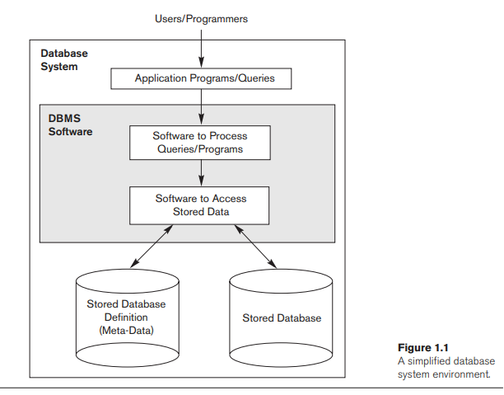
Features of a Database
♣ It is a persistent (stored) collection of related data.
♣ The data is input (stored) only once.
♣ The data is organised (in some fashion).
♣ The data is accessible and can be queried (effectively and efficiently).
Advantages of DBMS
- Controlling Redundancy
- Restricting Unauthorized Access
- Providing Persistent Storage for Program Objects
- Providing Storage Structures and Search Techniques for Efficient Query Processing
- Providing Backup and Recovery
- Providing Multiple User Interfaces
- Representing Complex Relationship among Data
- Enforcing Integrity Constraints
- Permitting Inferencing and Actions using Rules.
Disadvantages of DBMS
• Cost of Hardware & Software
• Cost of Data Conversion
• Cost of Staff Training
• Appointing Technical Staff
• Database Damage
- Characteristics of the Database Approach
- Self-describing nature of a database system.
- Insulation between programs and data, and data abstraction.
- Support of multiple views of the data.
- Sharing of Data and Multiuser Transaction Processing.
1.Self-describing nature of a database system
A fundamental characteristic of the database approach is that the database system contains not only the database itself but also a complete definition or description of the database structure and constraints. This definition is stored in the DBMS catalog, which contains information such as the structure of each file, the type and storage format of each data item, and various constraints on the data. The information stored in the catalog is called meta-data, and it describes the structure of the primary database.
The catalog is used by the DBMS software and also by database users who need information about the database structure. The DBMS software must work equally well with any number of database applications—for example, a university database, a banking database, or a company database—as long as the database definition is stored in the catalog.
2.Insulation between programs and data, and data abstraction
In traditional file processing, the structure of data files is embedded in the application programs, so any changes to the structure of a file may require changing all programs that access that file. By contrast, DBMS access programs do not require such changes in most cases. The structure of data files is stored in the DBMS catalog separately from the access programs. We call this property program-data independence.
In some types of database systems, such as object-oriented and object-relational systems, users can define operations on data as part of the database definitions. User application programs can operate on the data by invoking these operations through their names and arguments, regardless of how the operations are implemented. This may be termed program-operation independence.
The characteristic that allows program-data independence and program-operation independence is called data abstraction. A DBMS provides users with a conceptual representation of data that does not include many of the details of how the data is stored or how the operations are implemented.
3.Support of multiple views of the data
A database typically has many users, each of whom may require a different perspective or view of the database. A view may be a subset of the database or it may contain virtual data that is derived from the database files but is not explicitly stored. Some users may not need to be aware of whether the data they refer to is stored or derived. A multiuser DBMS whose users have a variety of distinct applications must provide facilities for defining multiple views.
4.Sharing of data and multiuser transaction processing
A multiuser DBMS, as its name implies, must allow multiple users to access the database at the same time. This is essential if data for multiple applications is to be integrated and maintained in a single database. The DBMS must include concurrency control software to ensure that several users trying to update the same data do so in a controlled manner so that the result of the updates is correct. For example, when several reservation agents try to assign a seat on an airline flight, the DBMS should ensure that each seat can be accessed by only one agent at a time for assignment to a passenger. These types of applications are generally called online transaction processing (OLTP) applications. A fundamental role of multiuser DBMS software is to ensure that concurrent transactions operate correctly and efficiently.
DBMS must enforce several transaction properties
▫ Isolation property- ensures that each transaction appears to execute in isolation from other transactions even though hundreds of transactions may be executing concurrently.
▫ Atomicity property- ensures that either all the database operations in a transaction are executed or none are.

- Database Users
Actors on Scene
- Database Administrators
In a database environment, the primary resource is the database itself, and the secondary resource is the DBMS and related software. Administering these resources is the responsibility of the database administrator (DBA). The DBA is responsible for authorizing access to the database, coordinating and monitoring its use and acquiring software and hardware resources as needed. The DBA is accountable for problems such as security breaches and poor system response time. In large organizations, the DBA is assisted by a staff that carries out these functions.
- Database Designers
Database designers are responsible for identifying the data to be stored in the database and for choosing appropriate structures to represent and store this data. These tasks are mostly undertaken before the database is actually implemented and populated with data. It is the responsibility of database designers to communicate with all prospective database users in order to understand their requirements and to create a design that meets these requirements. Database designers typically interact with each potential group of users and develop views of the database that meet the data and processing requirements of these groups. Each view is then analyzed and integrated with the views of other user groups. The final database design must be capable of supporting the requirements of all user groups.
- End Users
End users are the people whose jobs require access to the database for querying, updating, and generating reports; the database primarily exists for their use. There are several categories of end users:
- Casual end users occasionally access the database, but they may need different information each time. They use a sophisticated database query interface to specify their requests and are typically middle- or high-level managers or other occasional browsers.
- Naive or parametric end users make up a sizable portion of database end users. Their main job function revolves around constantly querying and updating the database, using standard types of queries and updates— called canned transactions—that have been carefully programmed and tested. The tasks that such users perform are varied. A few examples are:
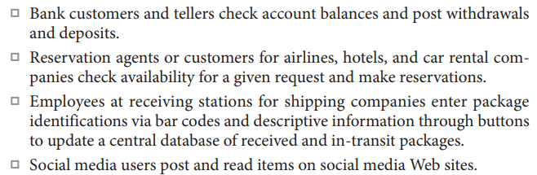
- Sophisticated end users include engineers, scientists, business analysts, and others who thoroughly familiarize themselves with the facilities of the DBMS in order to implement their own applications to meet their complex requirements.
- Standalone users maintain personal databases by using ready-made program packages that provide easy-to-use menu-based or graphics-based interfaces. An example is the user of a financial software package that stores a variety of personal financial data.
- System Analysts and Application Programmers (Software Engineers)
System analysts determine the requirements of end users, especially naive and parametric end users, and develop specifications for standard canned transactions that meet these requirements. Application programmers implement these specifications as programs; then they test, debug, document, and maintain these canned transactions. Such analysts and programmers—commonly referred to as software developers or software engineers—should be familiar with the full range of capabilities provided by the DBMS to accomplish their tasks.
Workers behind the Scene
They are associated with the design, development, and operation of the DBMS software and system environment. These persons are typically not interested in the database content itself.
- DBMS system designers and implementers design and implement the DBMS modules and interfaces as a software package. A DBMS is a very complex software system that consists of many components, or modules, including modules for implementing the catalog, query language processing, interface processing, accessing and buffering data, controlling concurrency, and handling data recovery and security. The DBMS must interface with other system software, such as the operating system and compilers for various programming languages.
- Tool developers design and implement tools—the software packages that facilitate database modeling and design, database system design, and improved performance. Tools are optional packages that are often purchased separately. They include packages for database design, performance monitoring, natural language or graphical interfaces, prototyping, simulation, and test data generation. In many cases, independent software vendors develop and market these tools.
- Operators and maintenance personnel (system administration personnel) are responsible for the actual running and maintenance of the hardware and software environment for the database system.
- Structured, Semi-structured and Unstructured Data

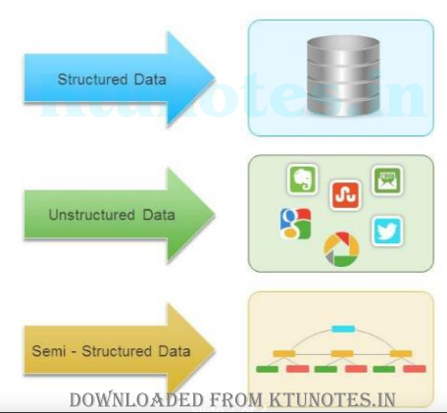

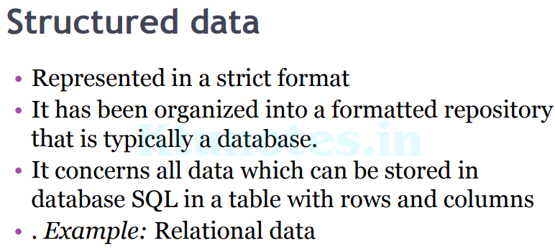

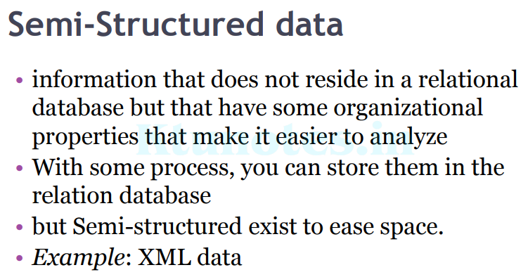
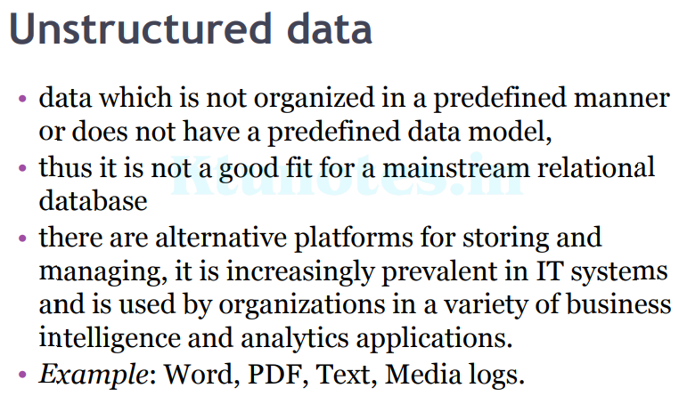
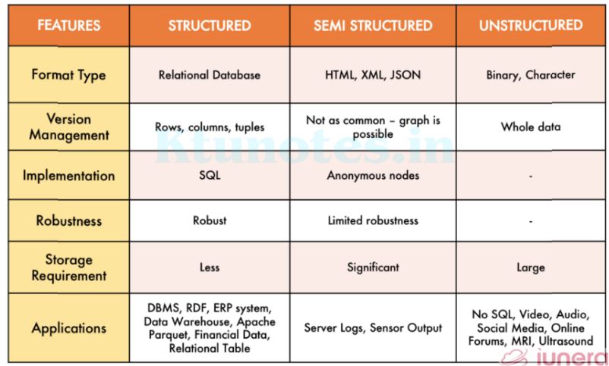
5. Data Abstraction, Data Model and Structure of a Database

Data Abstraction: Data abstraction generally refers to the suppression of details of data organization and storage, and the highlighting of the essential features for an improved understanding of data. One of the main characteristics of the database approach is to support data abstraction so that different users can perceive data at their preferred level of detail.
Data model: A collection of concepts that can be used to describe the structure of a database.
By structure of a database we mean the data types, relationships, and constraints that apply to the data. Most data models also include a set of basic operations for specifying retrievals and updates on the database.
Categories of Data Models
- High-level or conceptual data models
- Low-level or physical data models
- Representational (or implementation) data models
- Object data model
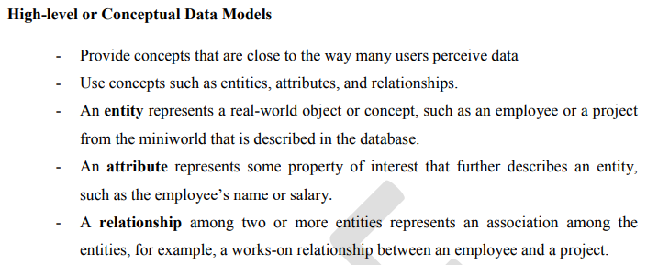
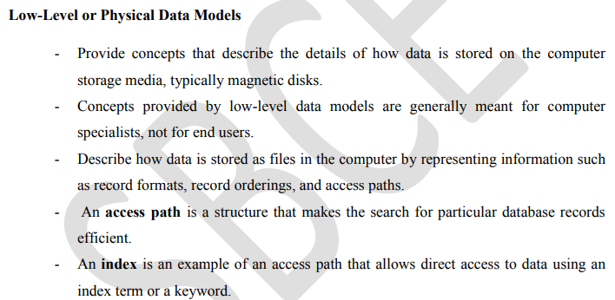
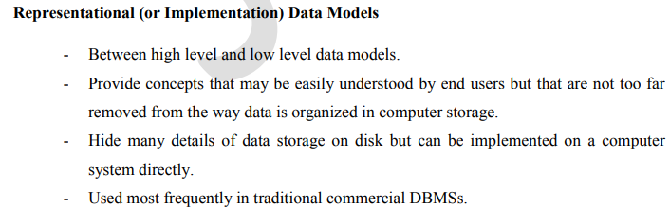 - They include the widely used relational data model, network and hierarchical
Models.
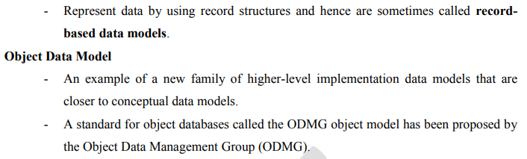
Schemas, Instances, and Database State
The description of a database is called the database schema, which is specified during database design and is not expected to change frequently. Most data models have certain conventions for displaying schemas as diagrams. A displayed schema is called a schema diagram. Figure 2.1 shows a schema diagram for the database shown in Figure 1.2. We call each object in the schema—such as STUDENT or COURSE—a schema construct.
A schema diagram displays only some aspects of a schema, for example, Figure 2.1 shows neither the data type of each data item nor the relationships among the various files.
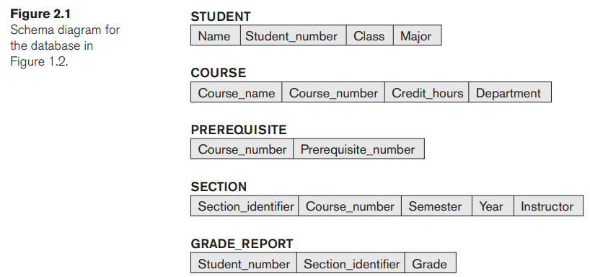

Figure 1.2 A database that stores student and course information.

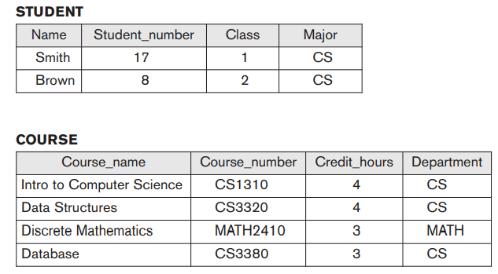

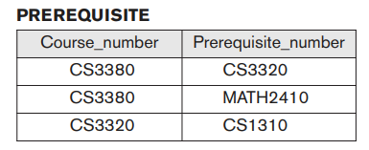
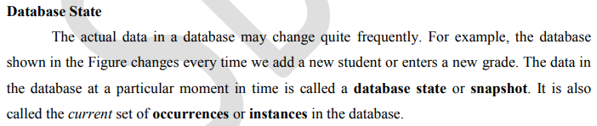
The DBMS stores the descriptions of the schema constructs and constraints—also called the meta-data—in the DBMS catalog so that DBMS software can refer to the schema whenever it needs to. The schema is sometimes called the intension, and a database state is called an extension of the schema. The schema is not supposed to change frequently, it is not uncommon that changes occasionally need to be applied to the schema as the application requirements change. This is known as schema evolution.
The Three-Schema Architecture

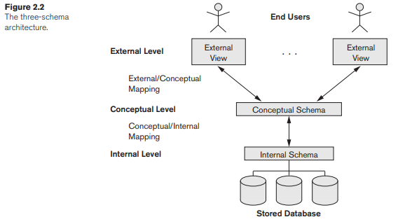
The goal of the three-schema architecture, is to separate the user applications from the physical database. In this architecture, schemas can be defined at the following three levels:
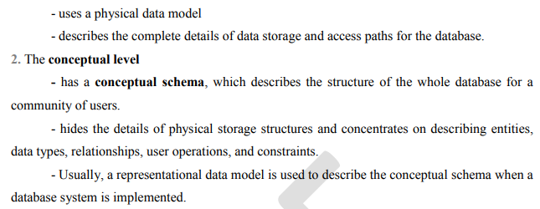
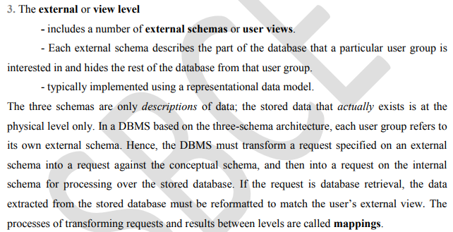
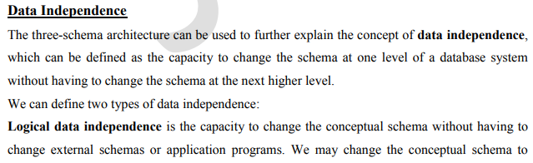
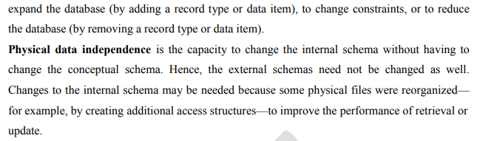
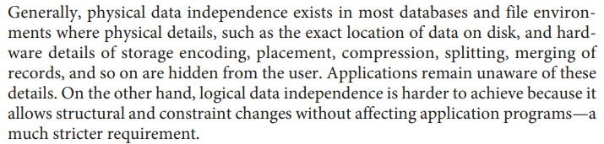
6.Database Languages and Interfaces
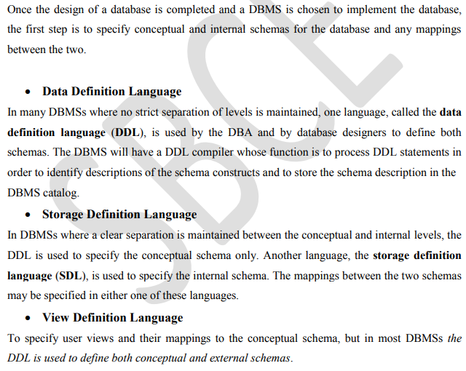
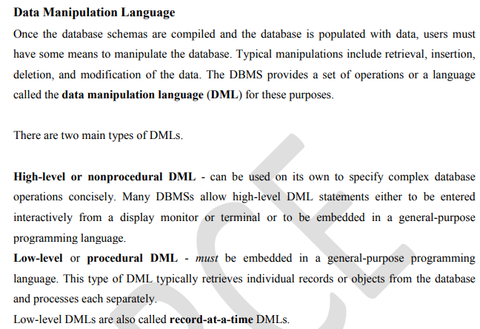
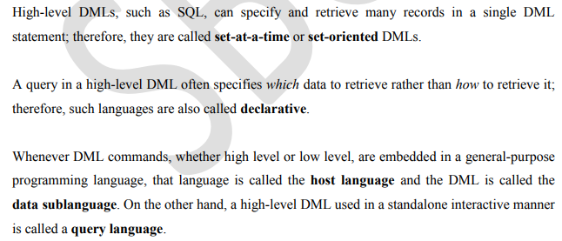
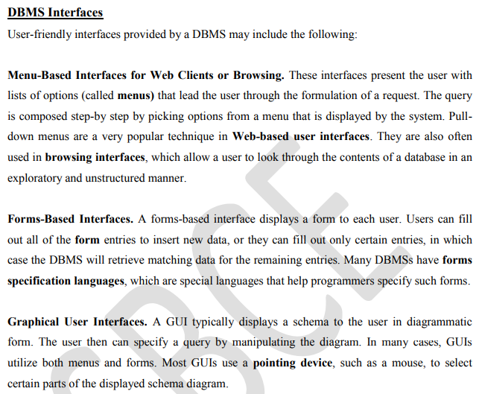
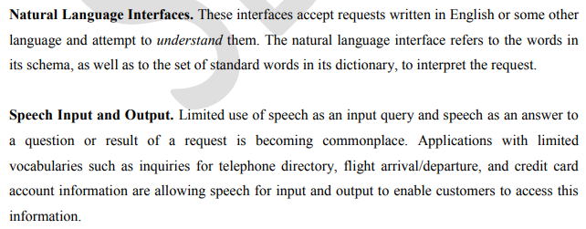
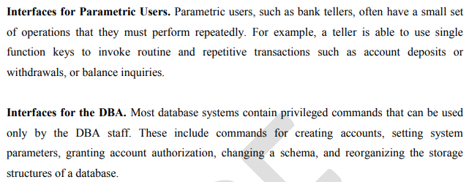
7. Database Architectures

Centralized DBMSs Architecture
Architectures for DBMSs have followed trends similar to those for general computer system architectures. Older architectures used mainframe computers to provide the main processing for all system functions, including user application programs and user interface programs, as well as all the DBMS functionality. Therefore, all processing was performed remotely on the computer system housing the DBMS, and only display information and controls were sent from the computer to the display terminals, which were connected to the central computer via various types of communications networks.
DBMS itself was still a centralized DBMS in which all the DBMS functionality, application program execution, and user interface processing were carried out on one machine.
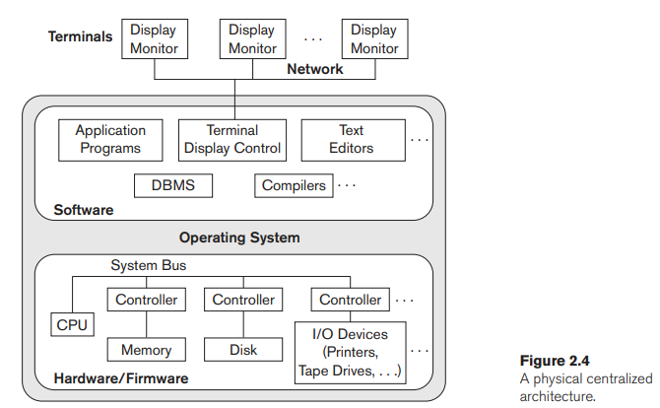

Basic Client/Server Architectures
The client/server architecture was developed to deal with computing environments in which a large number of PCs, workstations, file servers, printers, data base servers, Web servers, e-mail servers, and other software and equipment are connected via a network. The idea is to define specialized servers with specific functionalities. For example, it is possible to connect a number of PCs or small workstations as clients to a file server that maintains the files of the client machines. Another machine can be designated as a printer server by being connected to various printers; all print requests by the clients are forwarded to this machine.
A client in this framework is typically a user machine that provides user interface capabilities and local processing. When a client requires access to additional functionality— such as database access— that does not exist at that machine, it connects to a server that provides the needed functionality. A server is a system containing both hardware and software that can provide services to the client machines, such as file access, printing, archiving, or database access.
In general, some machines install only client software, others only server software, and still others may include both client and server software, as illustrated in Figure 2.6. Two main types of basic DBMS architectures were created on this underlying client/server framework: two-tier and three-tier.
Two-Tier Client/Server Architectures for DBMSs
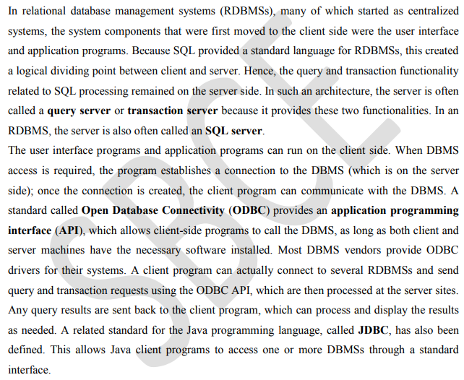
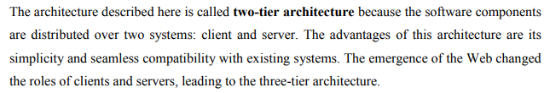
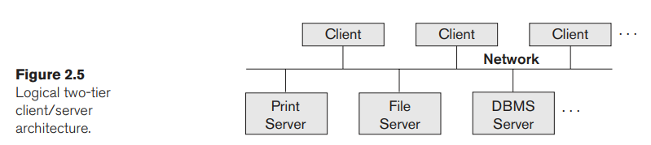

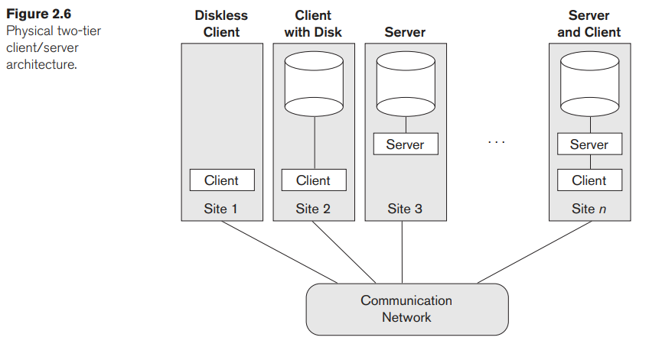

Three-Tier and n-Tier Architectures for Web Applications
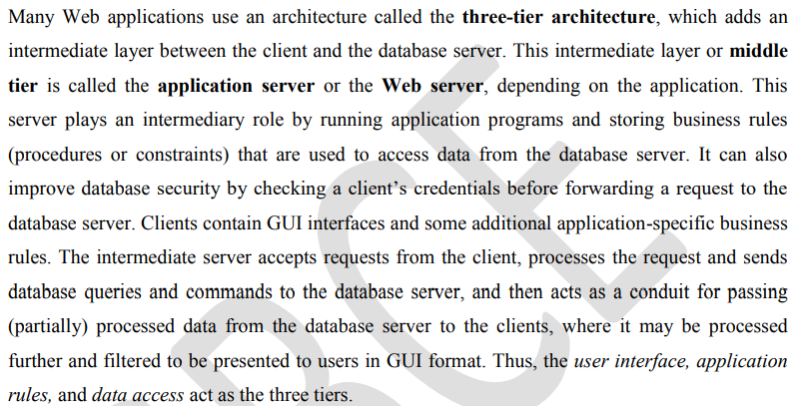
Figure 2.7(b) shows another view of the three-tier architecture used by database and other application package vendors. The presentation layer displays information to the user and allows data entry. The business logic layer handles intermediate rules and constraints before data is passed up to the user or down to the DBMS. The bottom layer includes all data management services. The middle layer can also act as a Web server, which retrieves query results from the database server and formats them into dynamic Web pages that are viewed by the Web browser at the client side. The client machine is typically a PC or mobile device connected to the Web.
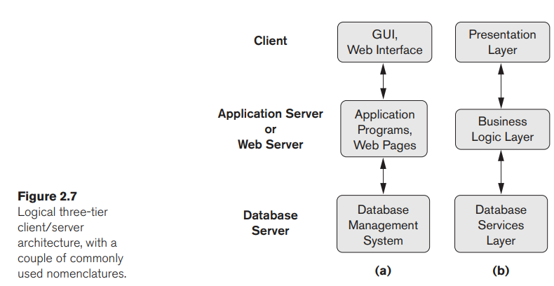
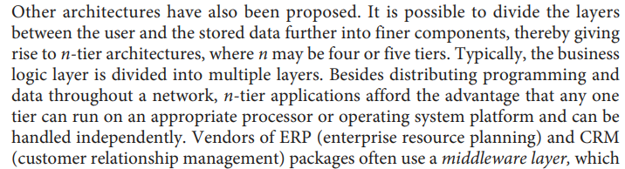
Classification of Database
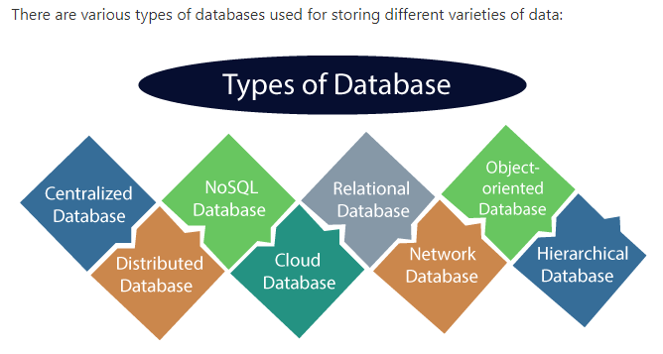

1) Centralized Database
It is the type of database that stores data at a centralized database system. It comforts the users to access the stored data from different locations through several applications. These applications contain the authentication process to let users access data securely. An example of a Centralized database can be Central Library that carries a central database of each library in a college/university.

Advantages of Centralized Database
- It has decreased the risk of data management, i.e., manipulation of data will not affect the core data.
- Data consistency is maintained as it manages data in a central repository.
- It provides better data quality, which enables organizations to establish data standards.
- It is less costly because fewer vendors are required to handle the data sets.

Disadvantages of Centralized Database
- The size of the centralized database is large, which increases the response time for fetching the data.
- It is not easy to update such an extensive database system.
- If any server failure occurs, entire data will be lost, which could be a huge loss.

2) Distributed Database
Unlike a centralized database system, in distributed systems, data is distributed among different database systems of an organization. These database systems are connected via communication links. Such links help the end-users to access the data easily. Examples of the Distributed database are Apache Cassandra, HBase, Ignite, etc.
We can further divide a distributed database system into:
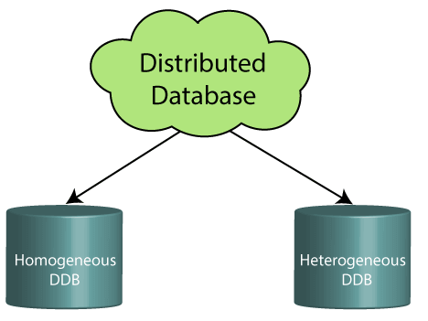
- Homogeneous DDB: Those database systems which execute on the same operating system and use the same application process and carry the same hardware devices.
- Heterogeneous DDB: Those database systems which execute on different operating systems under different application procedures, and carries different hardware devices.

Advantages of Distributed Database
- Modular development is possible in a distributed database, i.e., the system can be expanded by including new computers and connecting them to the distributed system.
- One server failure will not affect the entire data set.

3) Relational Database
This database is based on the relational data model, which stores data in the form of rows(tuple) and columns(attributes), and together forms a table(relation). A relational database uses SQL for storing, manipulating, as well as maintaining the data. E.F. Codd invented the database in 1970. Each table in the database carries a key that makes the data unique from others. Examples of Relational databases are MySQL, Microsoft SQL Server, Oracle, etc.

Properties of Relational Database
There are following four commonly known properties of a relational model known as ACID properties, where:
A means Atomicity: This ensures the data operation will complete either with success or with failure. It follows the 'all or nothing' strategy. For example, a transaction will either be committed or will abort.
C means Consistency: If we perform any operation over the data, its value before and after the operation should be preserved. For example, the account balance before and after the transaction should be correct, i.e., it should remain conserved.
I means Isolation: There can be concurrent users for accessing data at the same time from the database. Thus, isolation between the data should remain isolated. For example, when multiple transactions occur at the same time, one transaction effects should not be visible to the other transactions in the database.
D means Durability: It ensures that once it completes the operation and commits the data, data changes should remain permanent.

4) NoSQL Database
Non-SQL/Not Only SQL is a type of database that is used for storing a wide range of data sets. It is not a relational database as it stores data not only in tabular form but in several different ways. It came into existence when the demand for building modern applications increased. Thus, NoSQL presented a wide variety of database technologies in response to the demands. We can further divide a NoSQL database into the following four types:

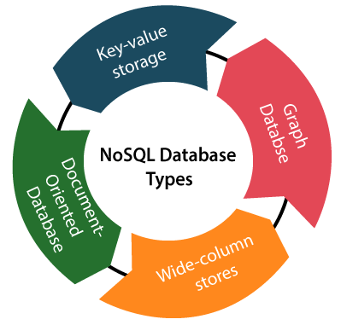
- Key-value storage: It is the simplest type of database storage where it stores every single item as a key (or attribute name) holding its value, together.
- Document-oriented Database: A type of database used to store data as JSON-like document. It helps developers in storing data by using the same document-model format as used in the application code.
- Graph Databases: It is used for storing vast amounts of data in a graph-like structure. Most commonly, social networking websites use the graph database.
- Wide-column stores: It is similar to the data represented in relational databases. Here, data is stored in large columns together, instead of storing in rows.

Advantages of NoSQL Database
- It enables good productivity in the application development as it is not required to store data in a structured format.
- It is a better option for managing and handling large data sets.
- It provides high scalability.
- Users can quickly access data from the database through key-value.

5) Cloud Database
A type of database where data is stored in a virtual environment and executes over the cloud computing platform. It provides users with various cloud computing services (SaaS, PaaS, IaaS, etc.) for accessing the database. There are numerous cloud platforms, but the best options are:
- Amazon Web Services(AWS)
- Microsoft Azure
- Kamatera
- PhonixNAP
- ScienceSoft
- Google Cloud SQL, etc.

6) Object-oriented Databases
The type of database that uses the object-based data model approach for storing data in the database system. The data is represented and stored as objects which are similar to the objects used in the object-oriented programming language.

7) Hierarchical Databases
It is the type of database that stores data in the form of parent-children relationship nodes. Here, it organizes data in a tree-like structure.
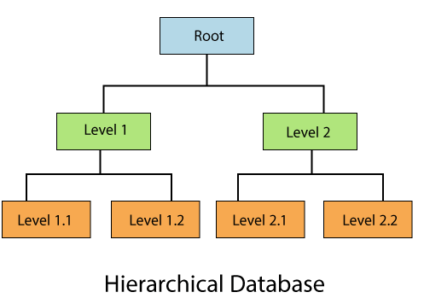

Data get stored in the form of records that are connected via links. Each child record in the tree will contain only one parent. On the other hand, each parent record can have multiple child records.

8) Network Databases
It is the database that typically follows the network data model. Here, the representation of data is in the form of nodes connected via links between them. Unlike the hierarchical database, it allows each record to have multiple children and parent nodes to form a generalized graph structure.

9) Personal Database
Collecting and storing data on the user's system defines a Personal Database. This database is basically designed for a single user.

Advantage of Personal Database
- It is simple and easy to handle.
- It occupies less storage space as it is small in size.

10) Operational Database
The type of database which creates and updates the database in real-time. It is basically designed for executing and handling the daily data operations in several businesses. For example, An organization uses operational databases for managing per day transactions.

11) Enterprise Database
Large organizations or enterprises use this database for managing a massive amount of data. It helps organizations to increase and improve their efficiency. Such a database allows simultaneous access to users.

Advantages of Enterprise Database:
- Multi processes are supportable over the Enterprise database.
- It allows executing parallel queries on the system.
DATABASE MODELING USING ENTITY-RELATIONSHIP MODEL (ER Model)

Basic Concepts of ER Diagrams
Entity Relationship diagram is a conceptual model that gives the graphical representation of the logical structure of the database. It shows all the constraints and relationships that exist among the different components.
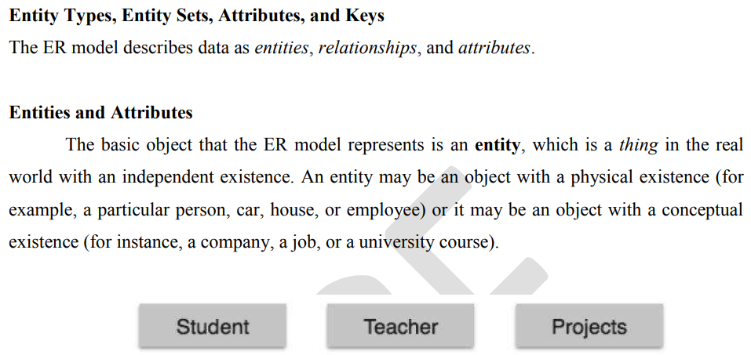
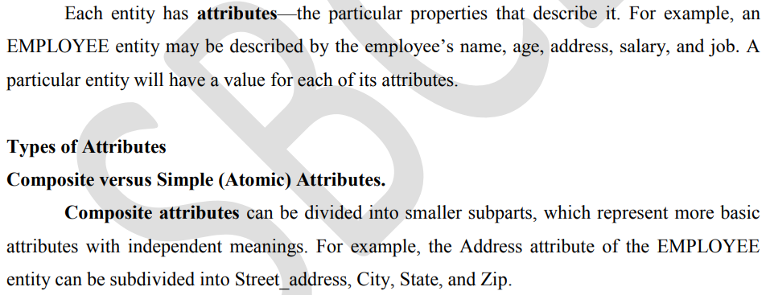
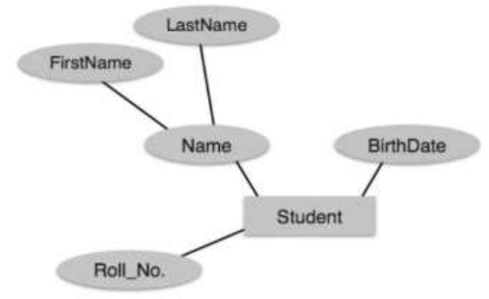
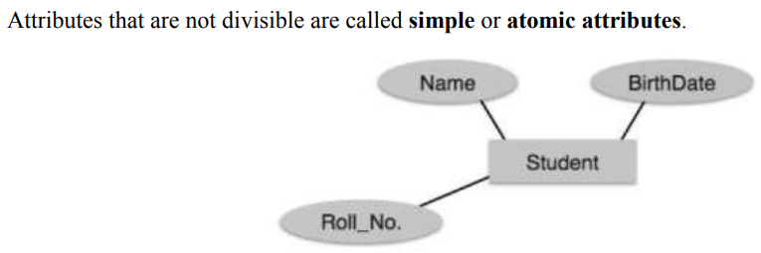
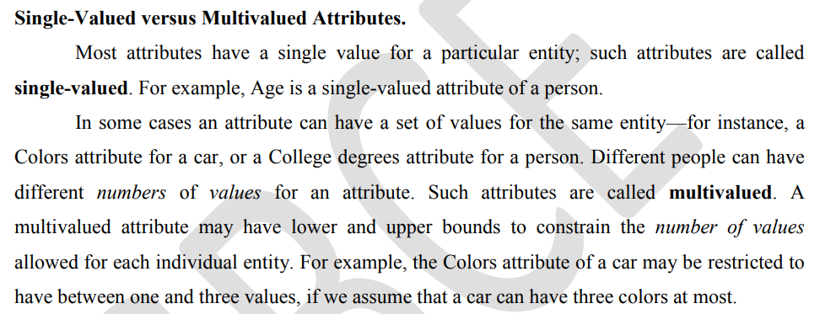
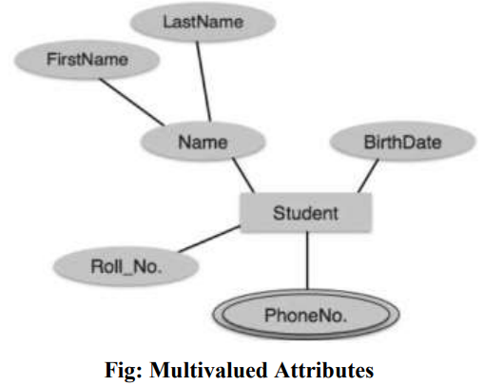
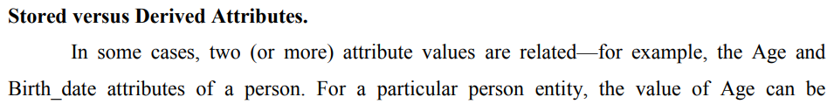
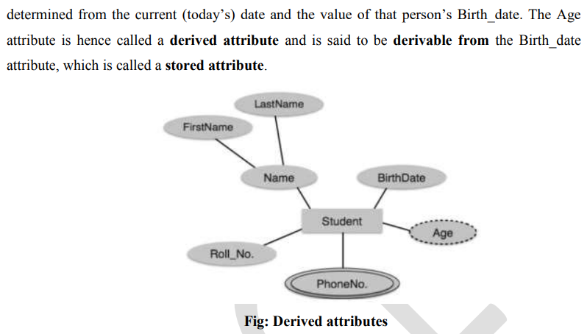
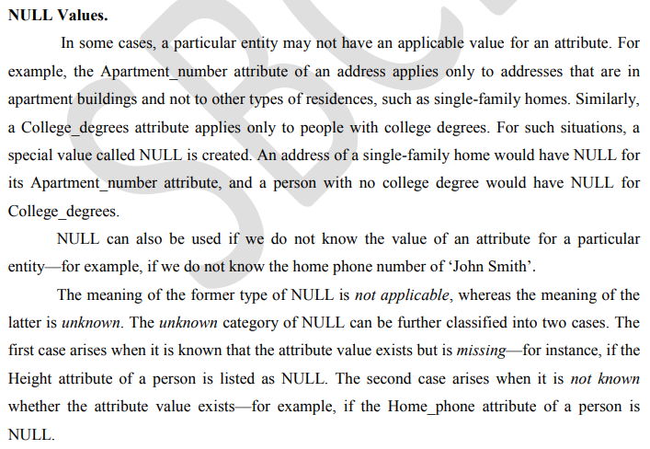
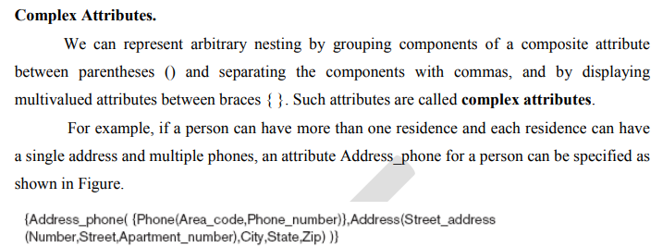

If any attribute has the combining property of multi values and composite attributes, then it is called a complex attribute. It means if one attribute is made up of more than one attribute and each attribute can have more than one value, then it is called a complex attribute.
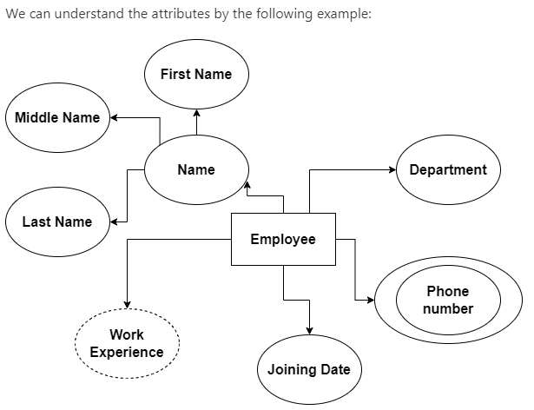
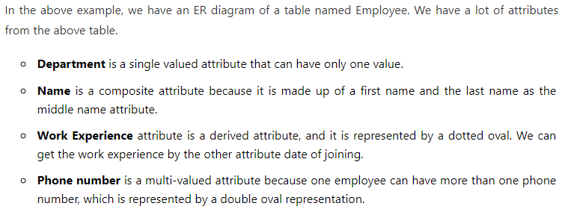
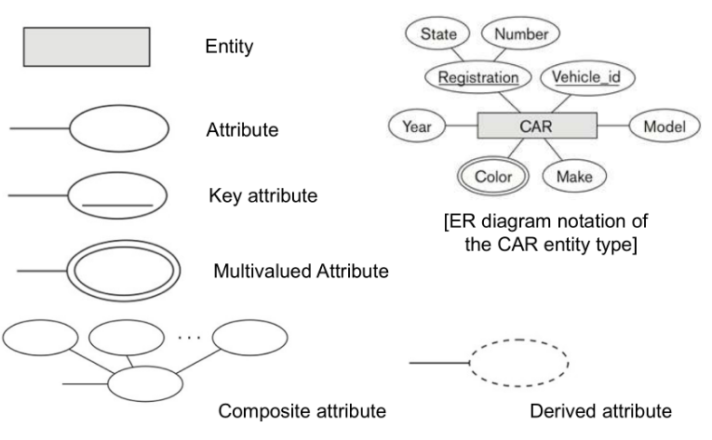
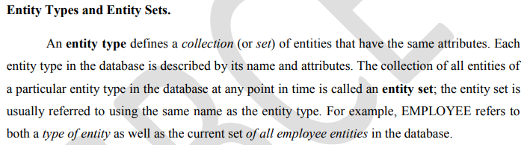
We use a rectangle to represent an entity type in the E-R diagram, not entity.

Entity Type
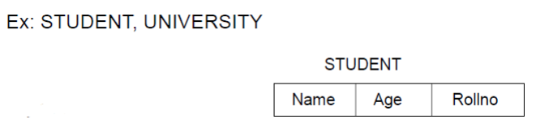

Entity Set
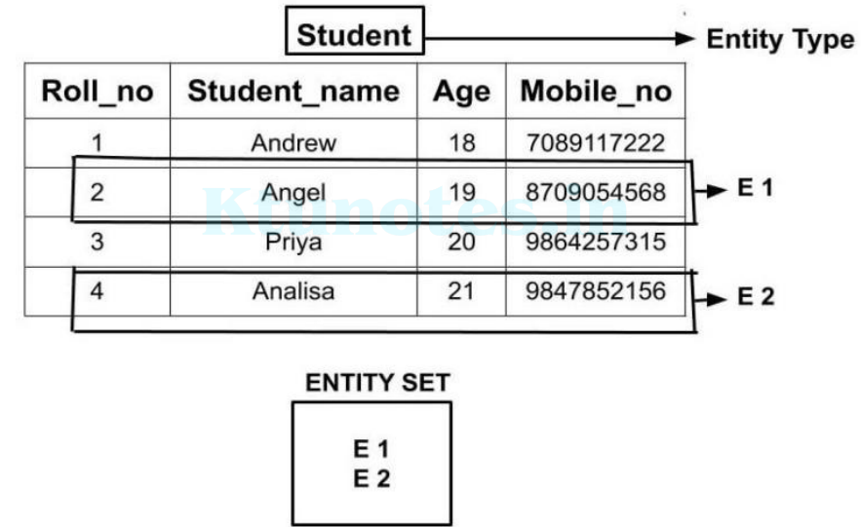
Attributes have some set of allowed or permitted values called Domain.
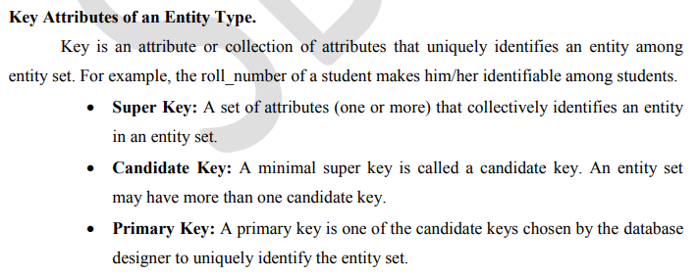

• Key attribute will never be a null valued attribute.
• Any composite attribute can also be a key attribute.
• There could be more than one key attributes for an entity type.
• Example: roll_no, enrollment _no
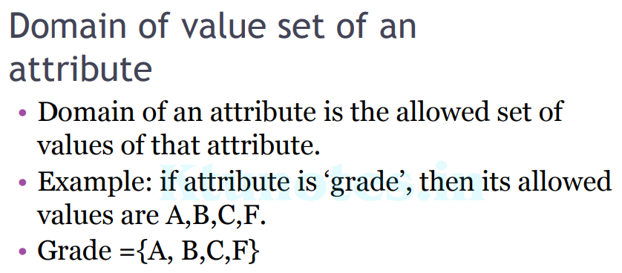
Domain is also called Value set.
Relationship Types, Sets, and Instances
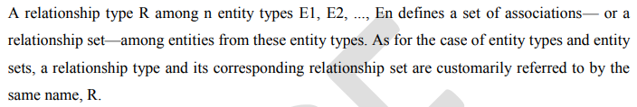
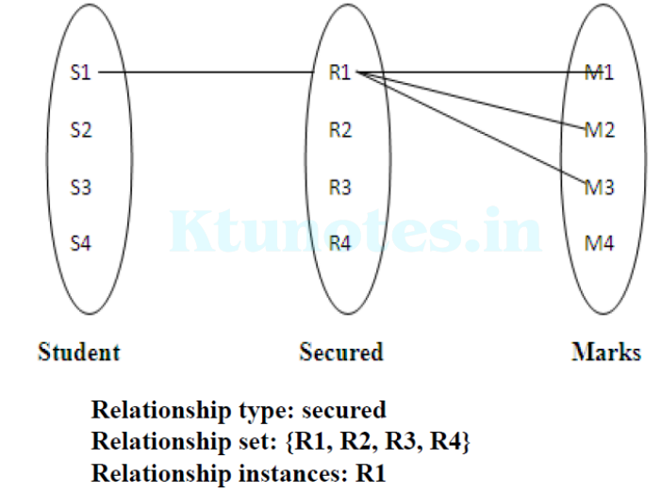
Relationship set is a set of relationships of the same type.

Consider a relationship type WORKS_FOR between the two entity types
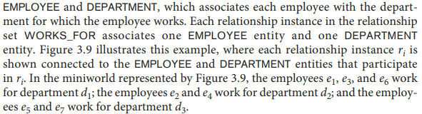
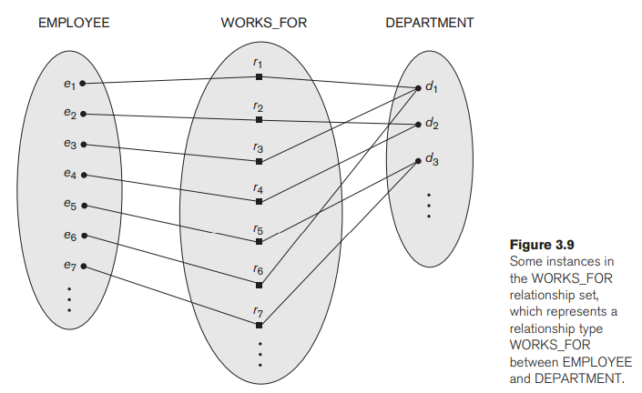
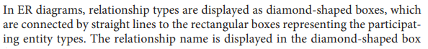
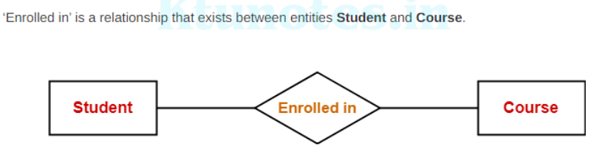
Relationship Degree, Role Names, and Recursive Relationships
Degree of a Relationship Type

It is the number of entity set which are participating in a relationship
▫ Unary relationship
▫ Binary Relationship
▫ Ternary Relationship
▫ N-ary Relationship
Unary relationship- Only one entity participates in a relationship set.
Ex: One person is married to only one person.
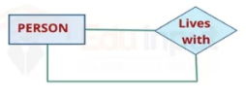
Binary Relationship- Two entity participates in a relationship set.

Ex:
Ex: Above said WORKS_FOR relationship is of degree two.

Ternary Relationship- Three entity participates in a relationship set.
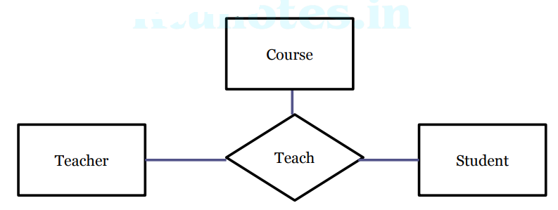

N-ary Relationship- n entity participates in a relationship set

Role Names and Recursive Relationships.

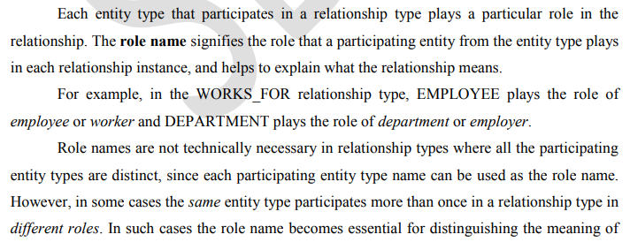
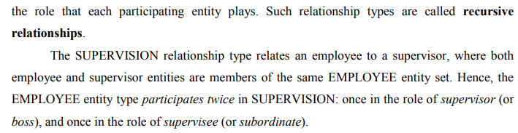
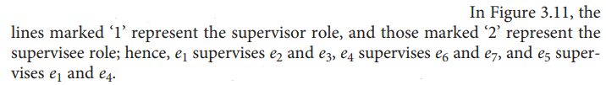
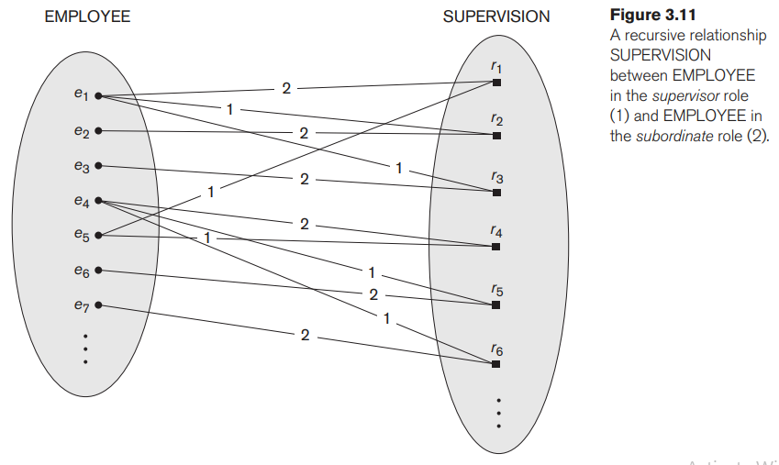
Constraints on Binary Relationship Types
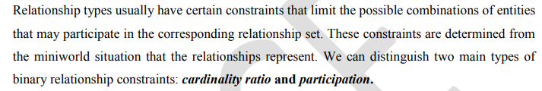
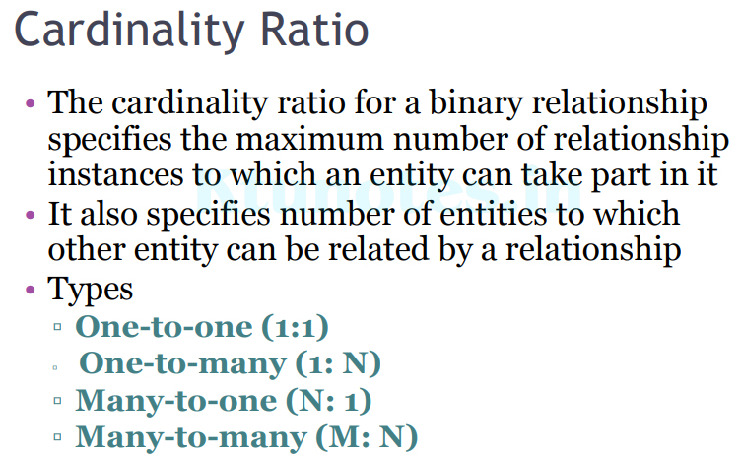
Cardinality ratio is also called Mapping cardinalities.
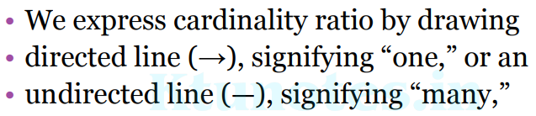

One-to-One Cardinality-
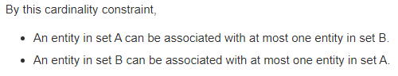
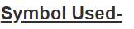
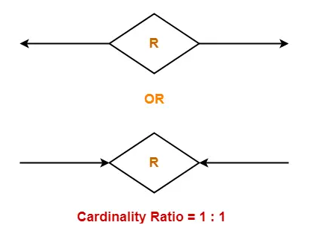

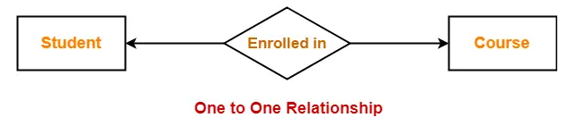


One-to-Many Cardinality-
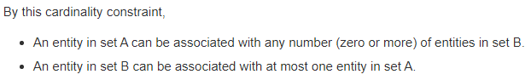
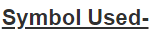
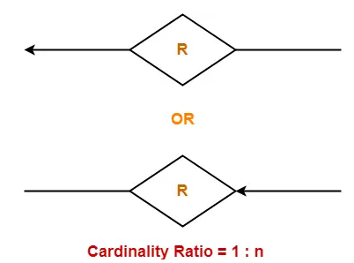

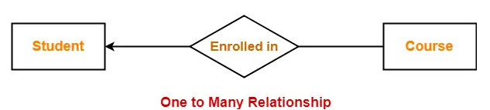
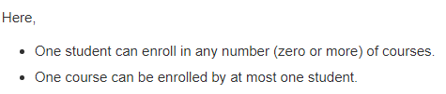

Many-to-One Cardinality-
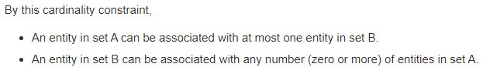
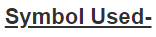
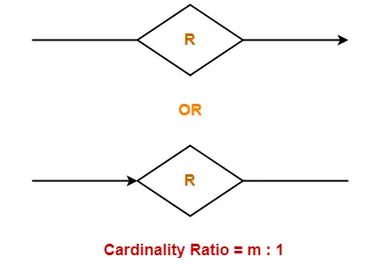

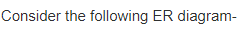
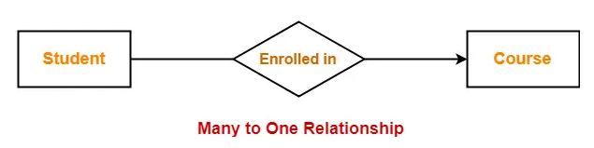
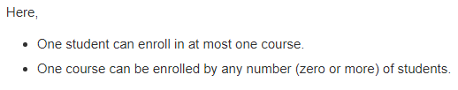

Many-to-Many Cardinality-
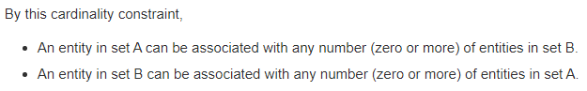

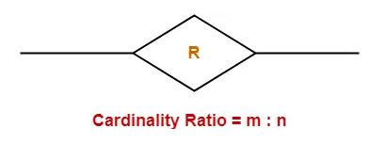

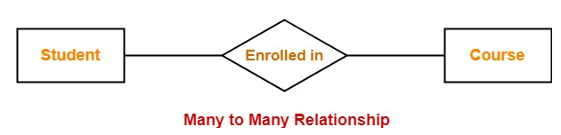
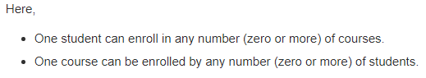

Participation Constraints and Existence Dependencies.
The participation constraint specifies whether the existence of an entity depends on its being related to another entity via the relationship type. This constraint specifies the minimum number of relationship instances that each entity can participate in and is sometimes called the minimum cardinality constraint.
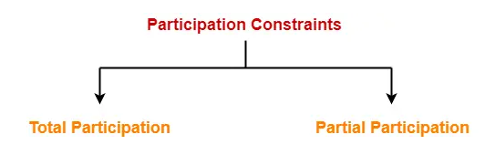
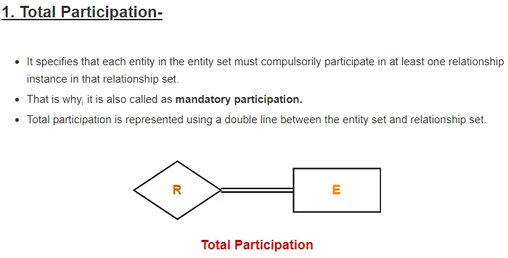
Total participation is also called existence dependency
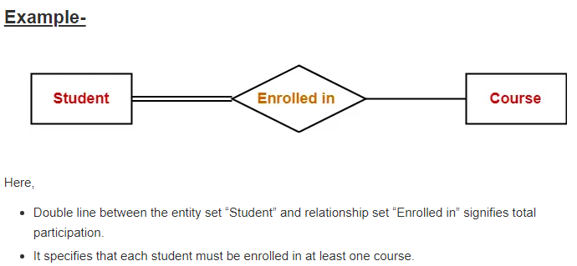
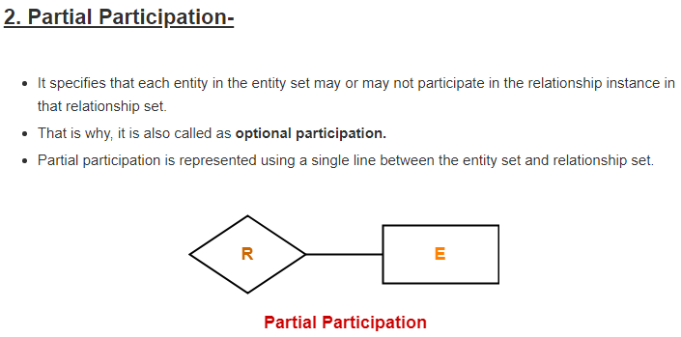
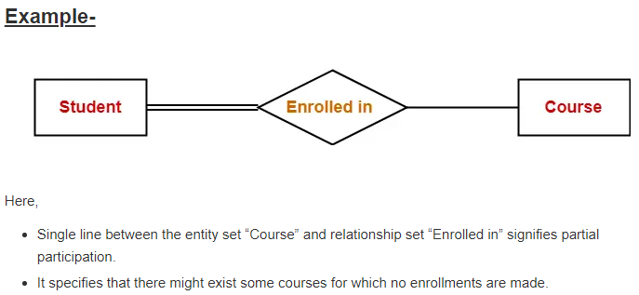
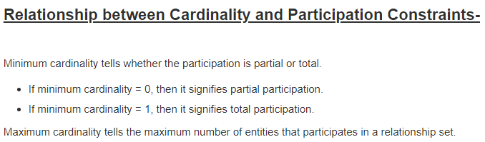

Entity Set in DBMS-
An entity refers to any object having-
- Either a physical existence such as a particular person, office, house or car.
- Or a conceptual existence such as a school, a university, a company or a job.
In ER diagram,
- Attributes are associated with an entity set.
- Attributes describe the properties of entities in the entity set.
- Based on the values of certain attributes, an entity can be identified uniquely.

Types of Entity Sets-

An entity set may be of the following two types-
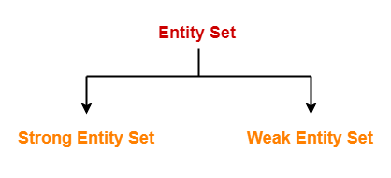

1. Strong Entity Set-

- A strong entity set is an entity set that contains sufficient attributes to uniquely identify all its entities.
- In other words, a primary key exists for a strong entity set.
- Primary key of a strong entity set is represented by underlining it.

Symbols Used-

- A single rectangle is used for representing a strong entity set.
- A diamond symbol is used for representing the relationship that exists between two strong entity sets.
- A single line is used for representing the connection of the strong entity set with the relationship set.
- A double line is used for representing the total participation of an entity set with the relationship set.
- Total participation may or may not exist in the relationship.

Example-

Consider the following ER diagram-
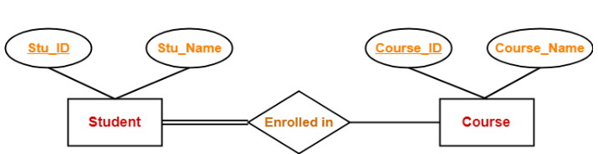
In this ER diagram,

- Two strong entity sets “Student” and “Course” are related to each other.
- Student ID and Student name are the attributes of entity set “Student”.
- Student ID is the primary key using which any student can be identified uniquely.
- Course ID and Course name are the attributes of entity set “Course”.
- Course ID is the primary key using which any course can be identified uniquely.
- Double line between Student and relationship set signifies total participation.
- It suggests that each student must be enrolled in at least one course.
- Single line between Course and relationship set signifies partial participation.
- It suggests that there might exist some courses for which no enrollments are made.

2. Weak Entity Set-

- A weak entity set is an entity set that does not contain sufficient attributes to uniquely identify its entities.
- In other words, a primary key does not exist for a weak entity set.
- However, it contains a partial key called as a discriminator.
- Discriminator can identify a group of entities from the entity set.
- Discriminator is represented by underlining with a dashed line.

NOTE-

- The combination of discriminator and primary key of the strong entity set makes it possible to uniquely identify all entities of the weak entity set.
- Thus, this combination serves as a primary key for the weak entity set.
- Clearly, this primary key is not formed by the weak entity set completely.

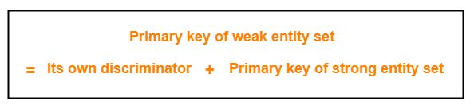

Symbols Used-

- A double rectangle is used for representing a weak entity set.
- A double diamond symbol is used for representing the relationship that exists between the strong and weak entity sets and this relationship is known as identifying relationship.
- A double line is used for representing the connection of the weak entity set with the relationship set.
- Total participation always exists in the identifying relationship.

Example-

Consider the following ER diagram-
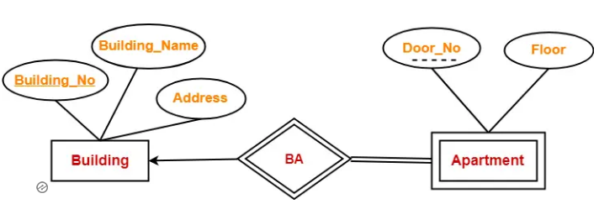

In this ER diagram,

- One strong entity set “Building” and one weak entity set “Apartment” are related to each other.
- Strong entity set “Building” has building number as its primary key.
- Door number is the discriminator of the weak entity set “Apartment”.
- This is because door number alone can not identify an apartment uniquely as there may be several other buildings having the same door number.
- Double line between Apartment and relationship set signifies total participation.
- It suggests that each apartment must be present in at least one building.
- Single line between Building and relationship set signifies partial participation.
- It suggests that there might exist some buildings which has no apartment.

To uniquely identify any apartment,
- First, building number is required to identify the particular building.
- Secondly, door number of the apartment is required to uniquely identify the apartment.
Thus, Primary key of Apartment
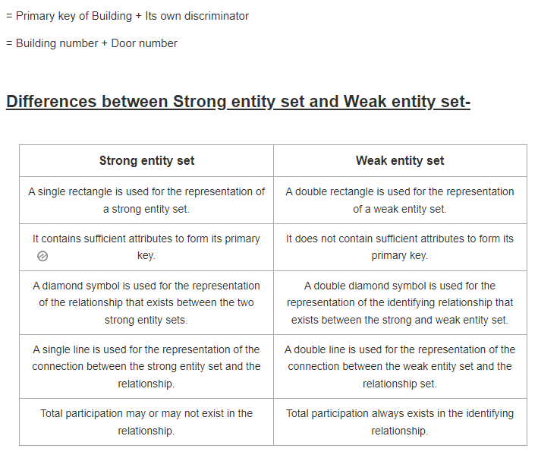
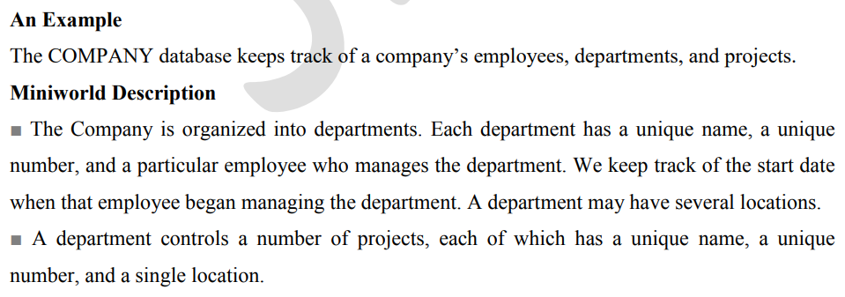
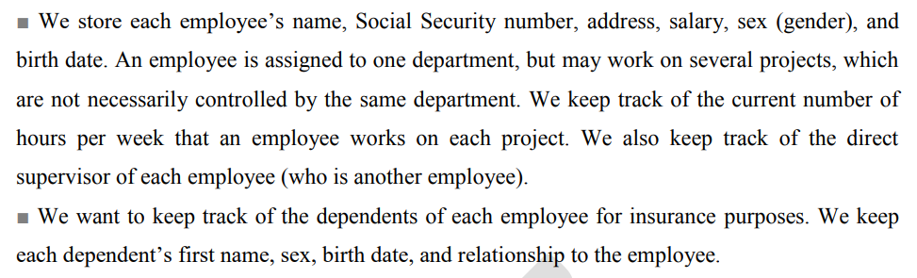
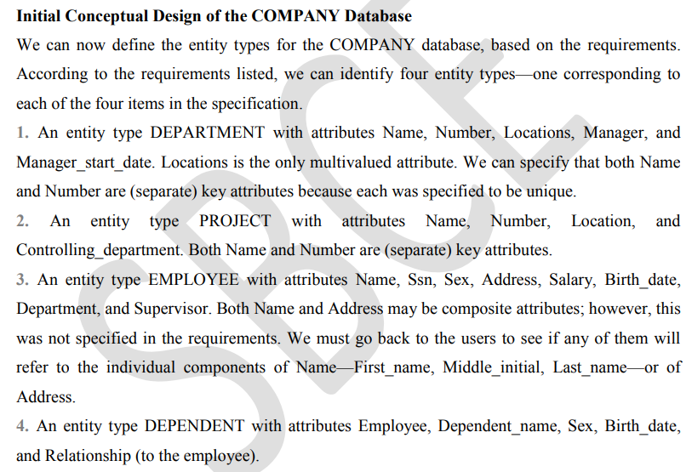
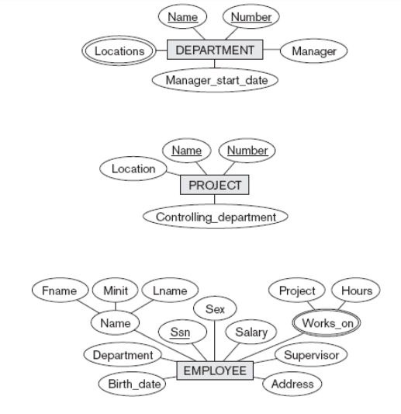
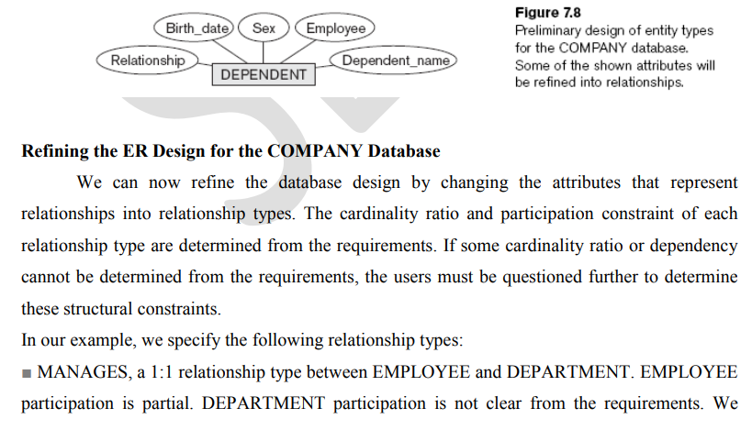
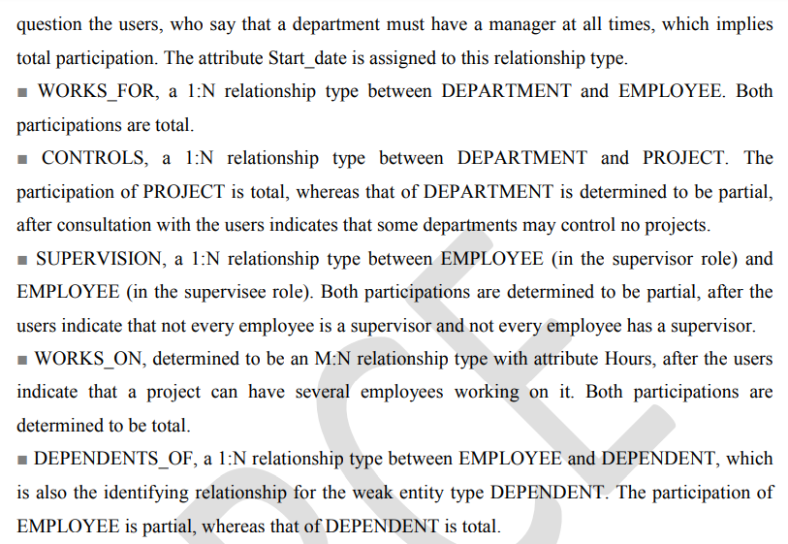
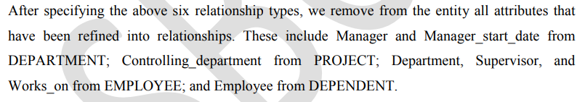
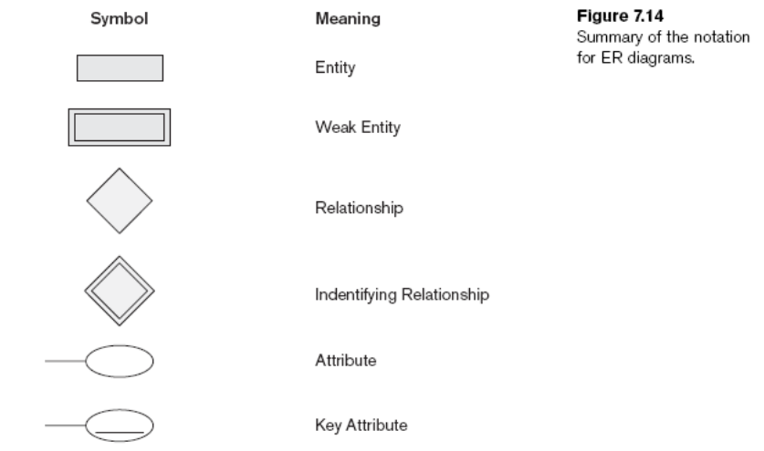
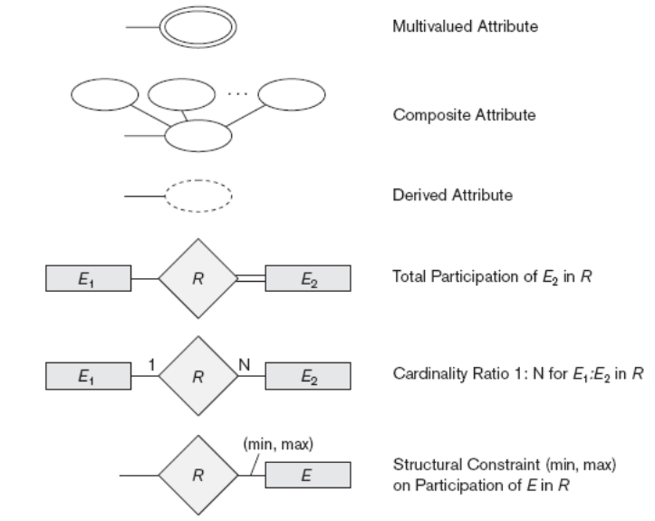
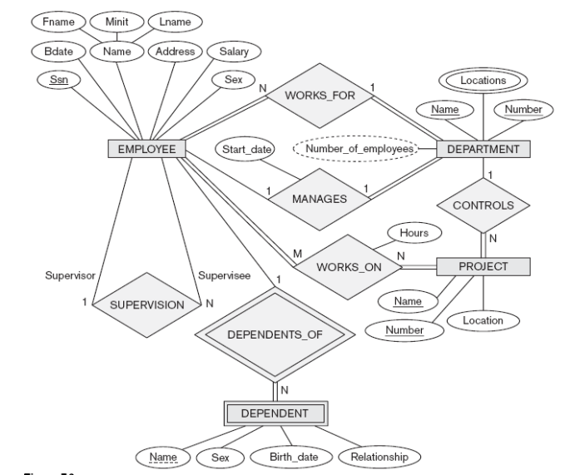

Relationship Types of Degree Higher than Two
The degree of a relationship type as the number of participating entity types and relationship type of degree two is called binary and a relationship type of degree three is called ternary.
